Post Lab
For the same hotel reservation database write SQL statement along with output to answer following queries:
- Display the HotelName and RoomNo which was reserved in the year 2001 and 2002, also display the Guest No who reserved the room at the time.

select h.hotelname, b.roomno, b.guestno, year(b.datefrom) year
from hotel h inner join booking b on h.hotelno = b.hotelno
where year(b.datefrom) = '2001' or year(b.datefrom) = '2002'

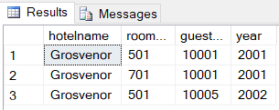

- Display the price of the “Family” type room in all hotels along with the HotelNames, HotelNo, RoomNo. NULL should be shown if a hotel doesn’t have a “Family” type room.
select h.hotelname, h.hotelno, r.roomno, r.type, r.price
from hotel h left outer join room r
on h.hotelno = r.hotelno and r.type = 'family'

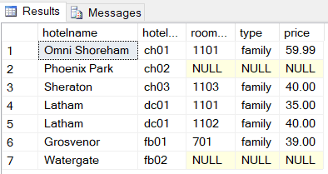

- Give the number of hotels present in each city.
select h.city, count(*) hotels
from hotel h
group by h.city

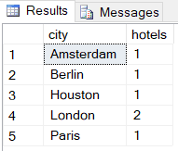

- What is the total revenue generated from all double rooms?
select sum(r.price) totalrevenue
from room r
where r.type = 'double'

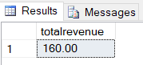

- How many different guests have made bookings till May, 2015?
select count(distinct b.guestno) guests
from booking b
where b.dateto <= '2015-05-01'

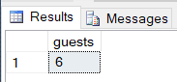

- Display the price and city name of the cheapest hotel rooms available in each city.

select min(r.price) minPrice, h.city
from room r inner join hotel h
on r.hotelno = h.hotelno
group by h.city

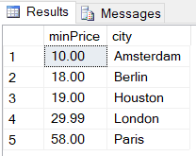
- Display the name(s) of the guest(s) who have reserved two or more than two rooms in a hotel.
select g.guestname, count(b.roomno) rooms
from guest g inner join booking b
on g.guestno = b.guestno
group by g.guestname
having count(b.roomno) > 1

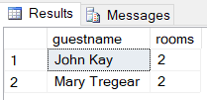

- Display the name, city of all the hotels along with the number of reservations it has, in descending order.
select h.hotelname, h.city, count(distinct b.datefrom) reservations
from hotel h inner join room r
on h.hotelno = r.hotelno inner join booking b
on r.hotelno = b.hotelno
group by h.hotelname, h.city
order by reservations desc

